CS 255 System Design Document Template

UML Diagrams

UML Use Case Diagram
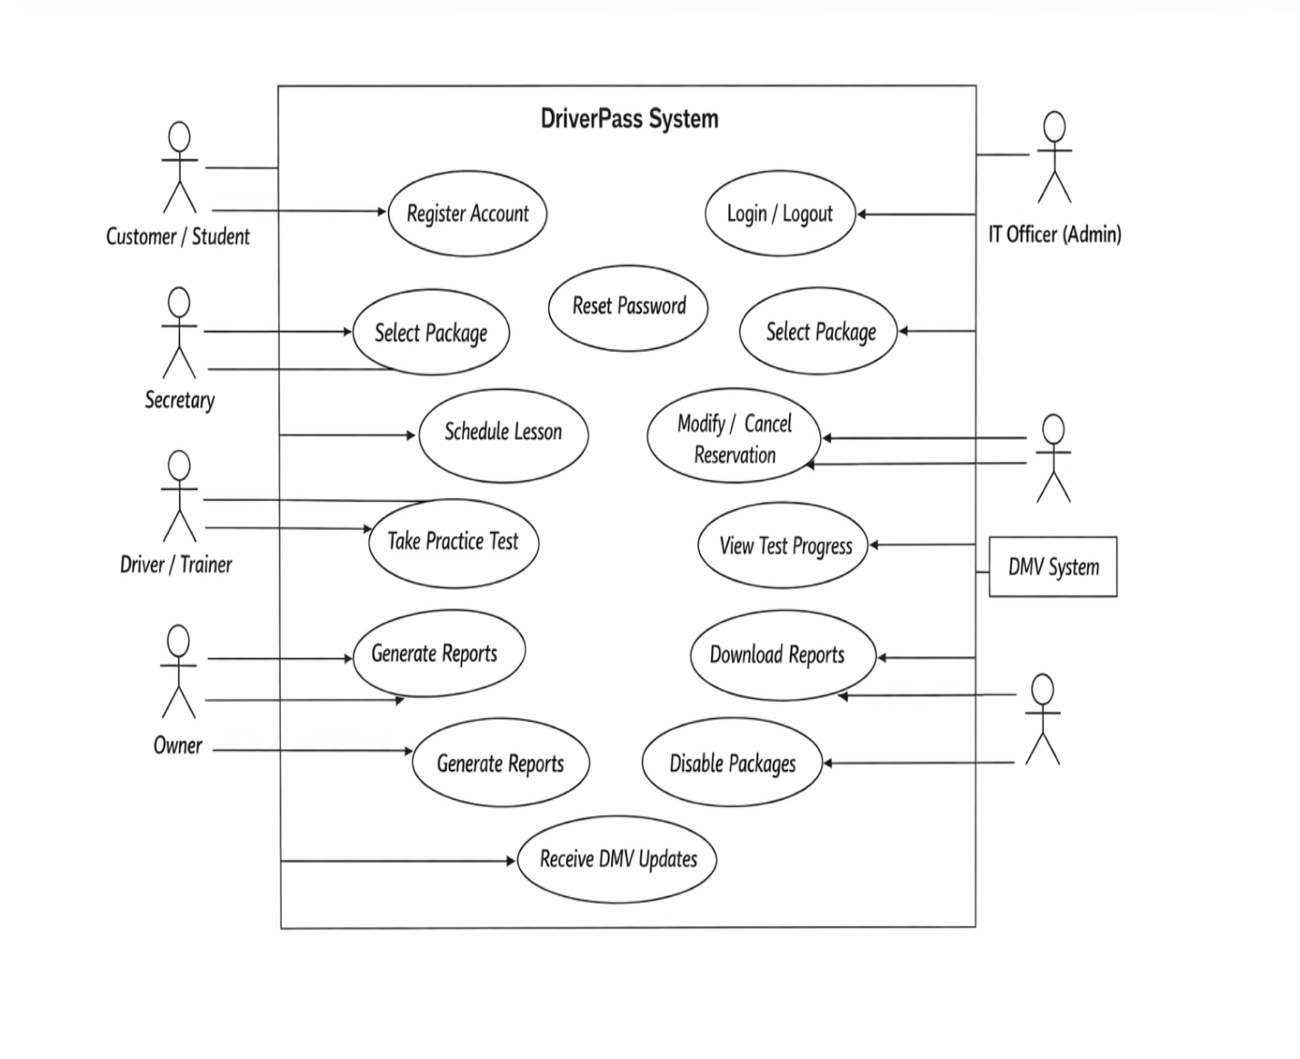

UML Activity Diagrams
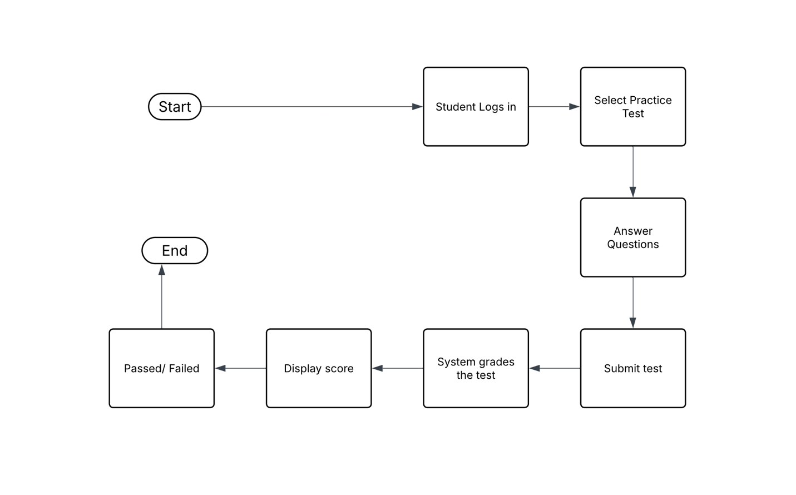
This is the UML activity diagram for DriverPass system. The diagram shows the step-by-step process of a student taking a practice test, starting from logging in, answering questions, submitting the test, and receiving a score with a pass or fail result. It helps explain how the system flows from start to finish.
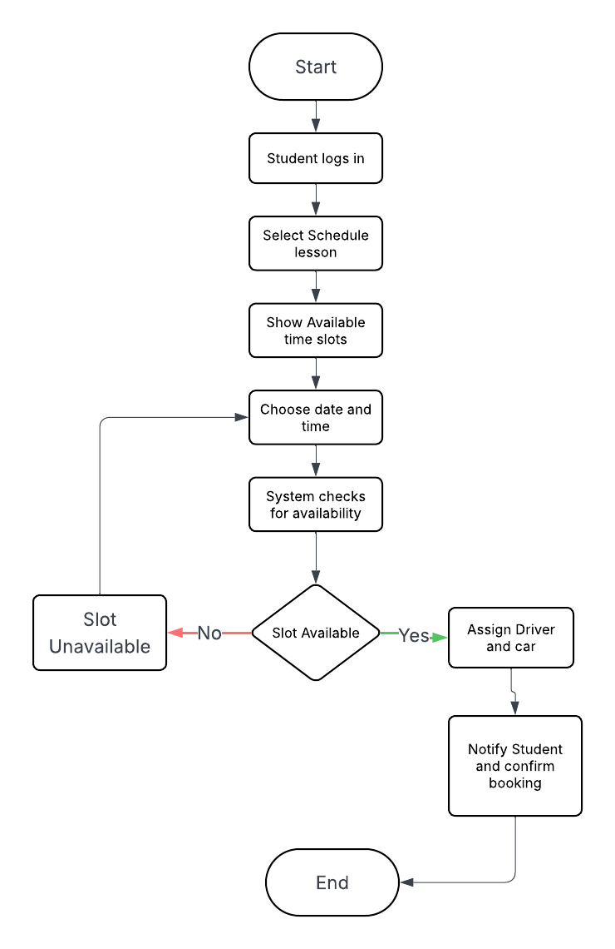
This UML activity diagram shows the process of a student scheduling a driving lesson in the DriverPass system. It begins with the student logging in, selecting a lesson, and choosing a date and time, after which the system checks availability. If a slot is available, the system assigns a driver and confirms the booking, but if not, the student must choose another time.

UML Sequence Diagram
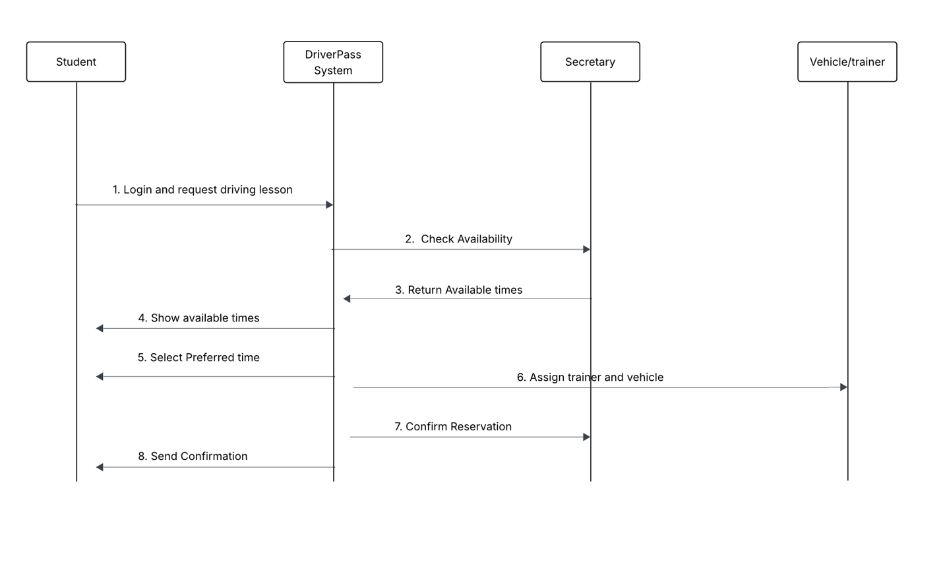
This UML sequence diagram shows how different parts of the DriverPass system interact when a student schedules a driving lesson. It illustrates the communication between the student, system, secretary, and vehicle/trainer as availability is checked, times are returned, and a preferred slot is selected. The process ends with assigning a trainer and vehicle, confirming the reservation, and sending a confirmation to the student.

UML Class Diagram

This UML class diagram represents the structure of the DriverPass system. It includes key classes such as Student, Package, Reservation, Lesson, Vehicle, and PracticeTest along with their attributes. The diagram also shows how these classes are connected and how data flows within the system.
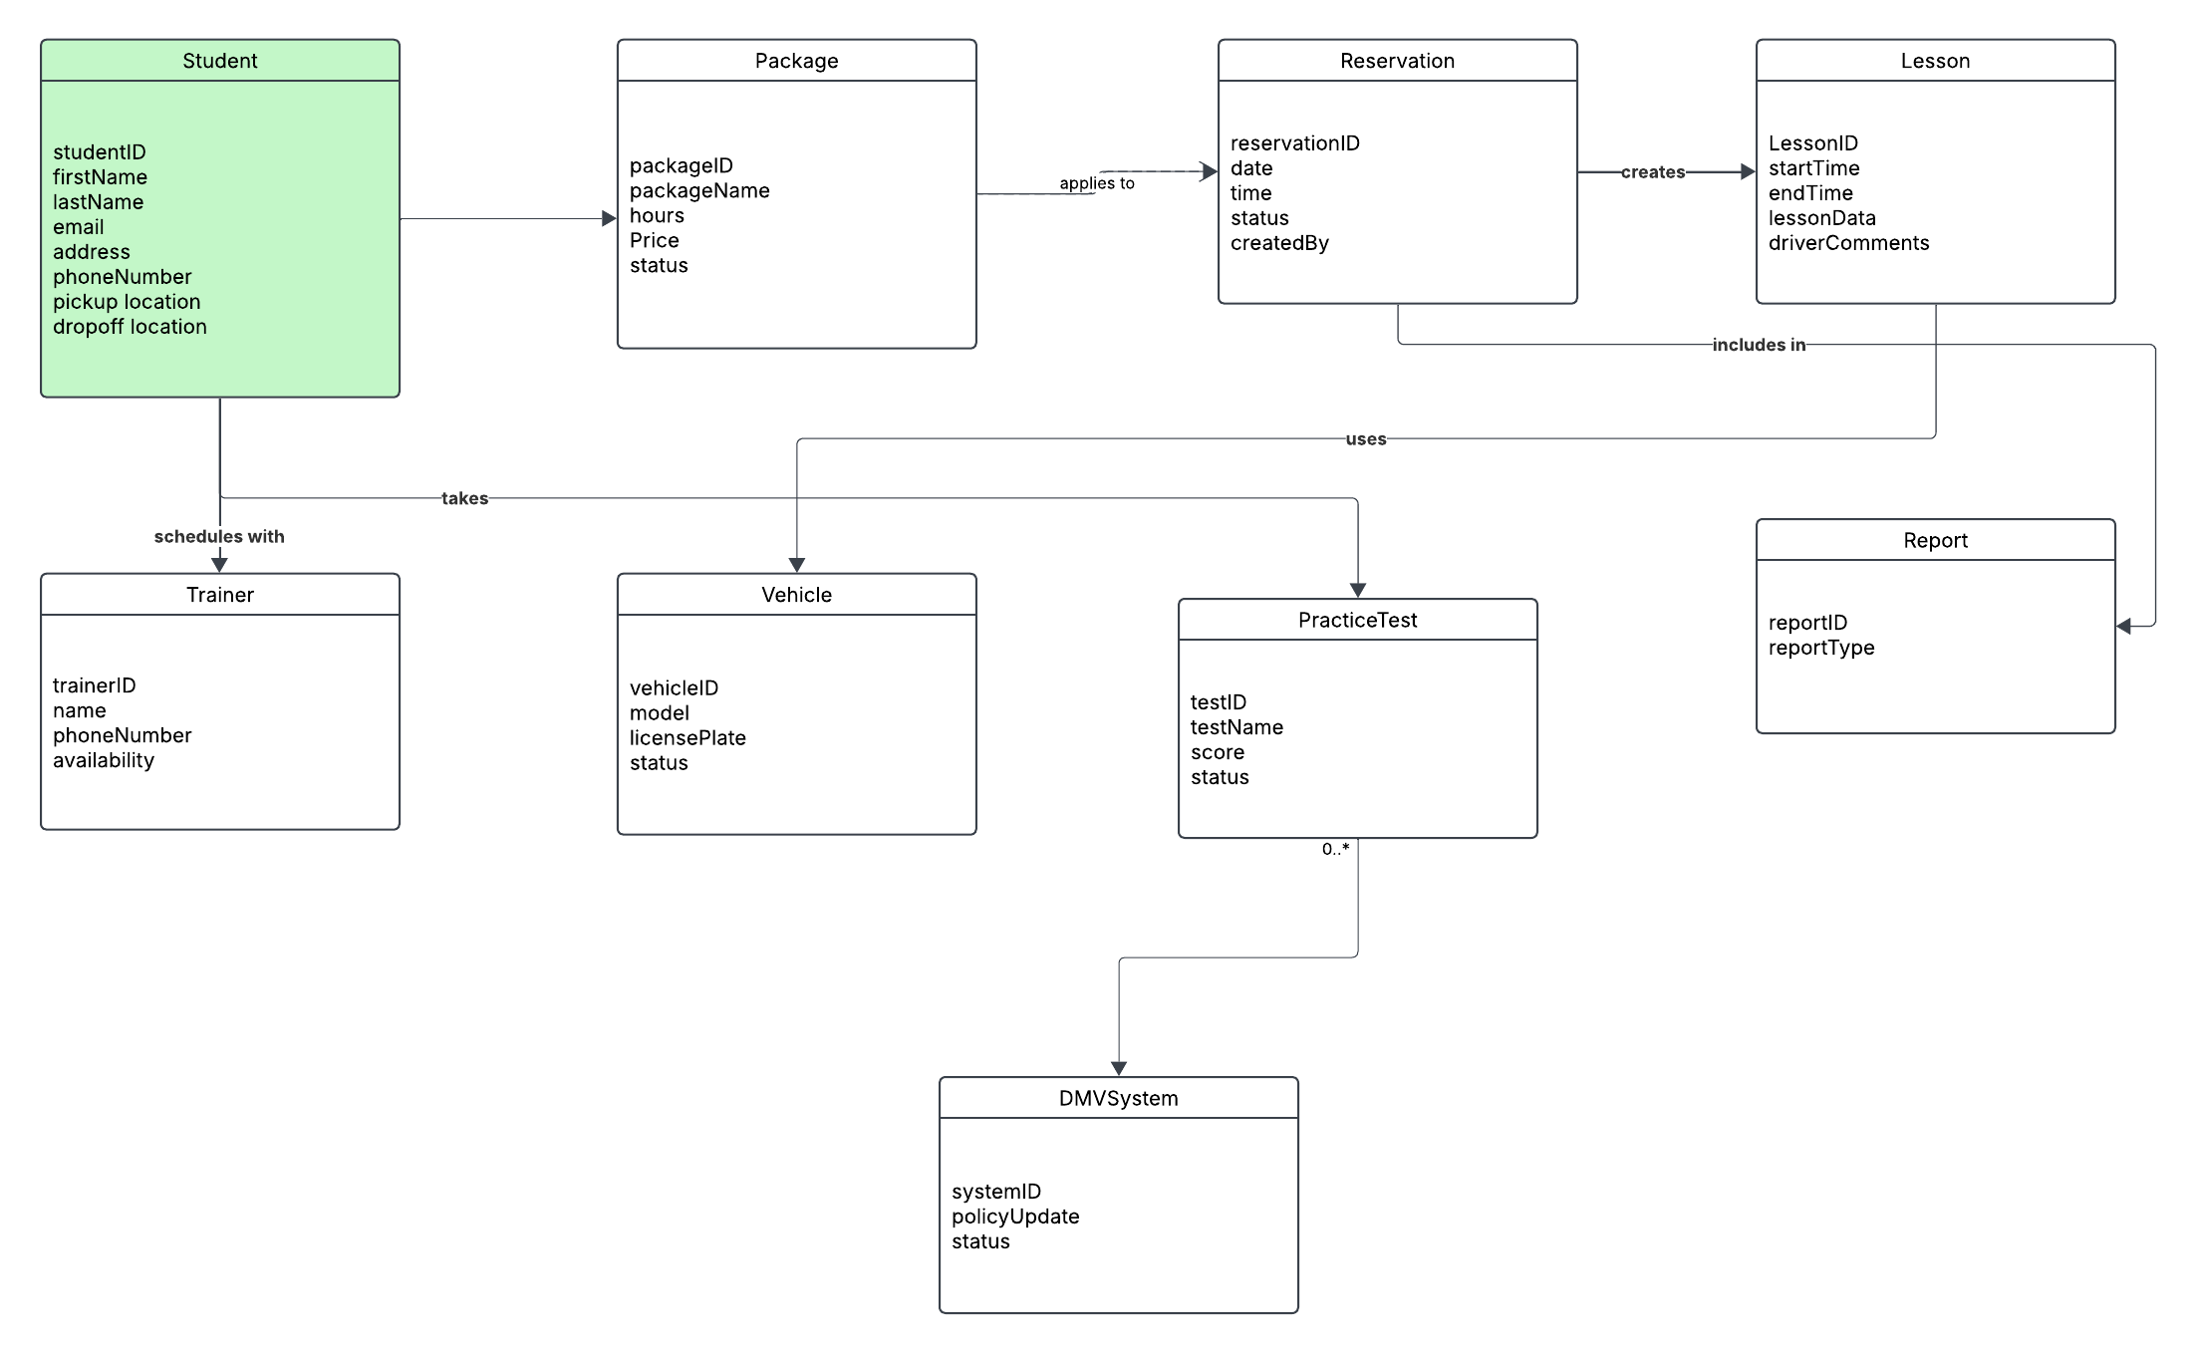

Technical Requirements

The DriverPass system requires a combination of hardware, software, tools, and infrastructure to support the proposed design.
Hardware: The DriverPass system should run on cloud-hosted servers so the business can access the system from different locations without maintaining its own physical servers. Employees and customers should be able to use a desktop computer, laptop, tablet, or smartphone with reliable internet access. At the business location, standard office computers, printers for reports, and secure payment-capable workstations would support daily operations.
Software: The system should be a web-based application that works through a standard web browser. The software should support online registration, lesson scheduling, package selection, practice tests, progress tracking, password reset, and reporting. It should also support role-based access so the owner, IT officer, secretary, trainer, and customer each see the functions appropriate to their responsibilities.
Tools: Development tools should support web design, database management, secure payment handling, and testing. The system should include reporting tools so the owner can download and review information in formats such as Excel. It should also include notification features for reservation confirmations and DMV content updates.
Infrastructure: DriverPass requested a cloud-based solution, so the system should use secure cloud hosting with backup, data recovery, and routine security protection. A centralized database should store customer accounts, reservations, lesson details, package information, test results, and activity logs. The system should also support integration with DMV updates so new rules, policies, or sample questions can be reflected in the practice materials. Because customers and staff will access the system online, the infrastructure should provide strong security, dependable uptime, and support for access from both computers and mobile devices.

